**GOVERNORS STATE UNIVERSITY**

**CPSC-8845-01_22SU: Advanced Database Concepts**

**PROJECT ABSTRACT**

# **MOVIE TICKET RESERVATION SYSTEM**

Student Name: Sanjay Boga

Student ID: 1241032

**Introduction**

During last era, motion pictures became very widely known. It demonstrates our cultures, and innumerable movies are launched every year by large international companies such as Netflix, Amazon, HBO, and others. Earlier, the one and only way to watch a film was in a "cinema," and humans became obsessed to even bluescreen. Theses days, thanks to the world of technological advancements, it becomes much simpler to watch a film.

Having followed the tremendous feedback from moviegoers over the last few decades, a new industry, movie ticket booking, has emerged as a subset of the same industry. With the expansion of cinema across the globe, distributing and purchasing tickets has become one of the most difficult tasks. To address this issue, a movie ticket reservation system has been implemented. This allows moviegoers to purchase movie tickets in a matter of minutes from anywhere in the world. The objective of movie ticket reservation system is provide moviegoers with a service that allows them to reserve seats in movie theaters anywhere and at any moment. Movie information is publicly available. The customer can quickly learn about the new cinema and then decide.

It is a mechanism that is accessible through the internet. Moviegoers  can purchase tickets online and cancel their seats at a later date. To improve the reimbursement feature, all consumers must sign up to become a member before purchasing a ticket.

**Implementation**

Movie ticket reservation system is designed and develope in .Net framework which includes multiple modules such as login, registration, movie viewing, ticket booking and many more.

**Front-End Stack**: ASP.NET, HTML, CSS, BOOTSTRAP, JAVASCRIPT, C#

**Backend-End Stack**: Oracle DB

**Software**: Visual Studio Community Edition, SQL Developer 2019

**UML Diagram**

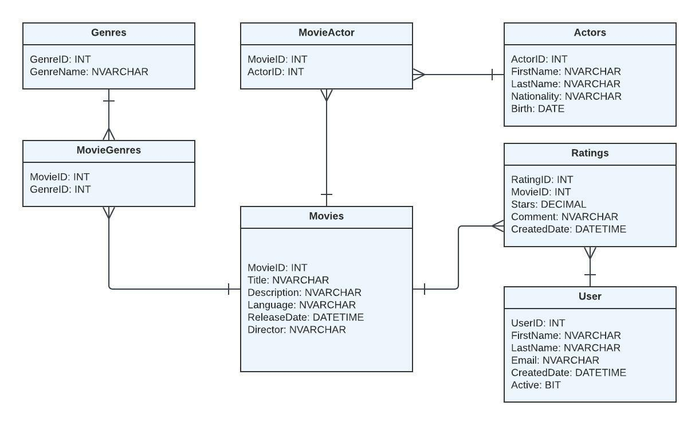

# **Schemas in Movie ticket reservation system**

1. **Movies**

This table is the primary table which keep track of all the movies which user wants to books through our application i.e. Talkies

1. **Genres**

This table is used to hold the different categories of movies such as crime, romance, thriller and many more.

1. **MovieGenres**

This schema shows the link between two table i.e. movie and genres and link both of them using foreign key to fetch the category of gerne movie belongs to.

1. **Actors**

This table stores the actors details who has worked as a primary lead actor in the respective movie which is linked by another table called MovieActor.

1. **MovieActor**

MovieActor is a relational table between actor and movie which link up using foreign key to fetch the lead actor working in respective films.

1. **Rating**

This table keep holds of number of stars/rating received by IMDB or users.

1. **User**

This is the user details table which is specific to our application. Talkies allows the user to first register in our portal and then allow to book the movie tickets.